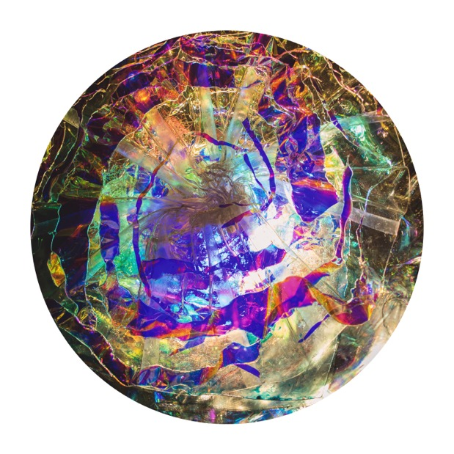

Creative Skills and Processes
Unboxed

New Creative Art Courses 2018-2019

For Adults and Young Artists

www.lornacarmenmcneill.com
lorna@lornacarmenmcneill.com
+44 (0) 07967-978821

Images below are artwork produced by students on the courses.

Creative Skills and Processes Unboxed are a collection of innovative, experiential art courses which create a space and structure for students to learn the necessary skills to connect to and express what they are most interested in, what matters most to them, including their core motivations, creative interest and intent. The courses facilitate this through a dialogue between drawing, painting, mixed media and sculpture, and where appropriate installation, to open up new unexpected creative directions. Through specific skills training incorporating all aspects of the design process, students explore multi-sensory connectedness, where relevant including music, sound, word and movement. Multi-sensory approaches are incorporated to enable enhanced brain function, accelerated learning, improved memory, well-being and whole person engagement.

Within each course, students are invited to apply learning to a theme of their choice, culminating in a final piece which unites elements explored.

OPTIONS FOR COURSES

It is recommended that students start with the Unlocking Creativity Foundation as the other develop from it.

Students can build up a portfolio of work or develop new possibilities from an existing portfolio. It is therefore also suitable and can be adapted for GCSE, A level and Foundation students.

Course students in non- art professions or other specialities within the arts who want to develop creative ideas for cross-fertilisation, can bring their projects or field of enquiry, and help will be available to apply and integrate learning in new exciting ways. Bespoke options and workshops tailored to specific needs are available. Please contact me for details and prices. Alternatively below are some possible options:

Option 1

Foundation course of 5 days (or 8-10 ½ days), followed by the equivalent of 5 days of a Creative Processes Unboxed course.

Option 2

Foundation course of 5 days followed by 6x4 days of unboxed courses over 1 year

Option 3

Foundation course of 5 days followed by 1 weekend per month for 6 months on 3 different unboxed courses and an additional 1 day per month of mentoring group.

FOLLOW-ON

Anyone who has completed the foundation can attend any of the courses and work in their own space to develop their work supported with specialist tutoring input.

Mentoring groups

For people who have already completed one or more of the unboxed courses – a monthly group meeting is available to explore and develop work that has already been initiated.

BESPOKE courses can also be created.

The courses below can all be tailored to working with young artists 12-18 or older.

FOUNDATION: UNLOCKING CREATIVITY

This exciting and innovative course is designed to help develop creative expression, allowing creativity to flow unhindered. Students will explore a range of art materials and learn different skills (drawing, painting, sculpture, collage) to stimulate unexpected creative discovery. There is an opportunity to create a series of art pieces and explore a concept of choice which will culminate in one or a series of unique creations. This course facilitates active experimentation and an exploration of creativity via all the senses. Skills in each of the above disciplines, will be developed throughout the course, to support students to optimise their creative expression.

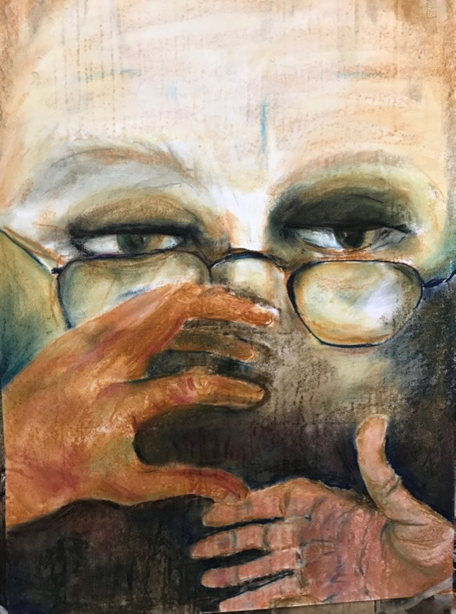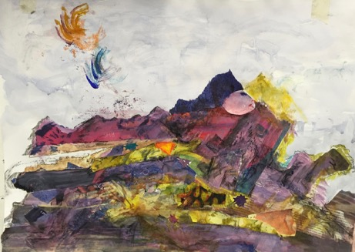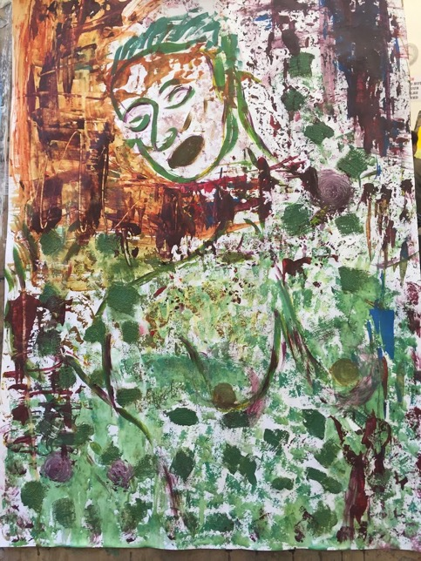
CORE FOLLOW-ON COURSES

Exploring Movement through Mixed Media
Everything is in a state of perpetual motion and change, whether we realise it or not. Even mountains are moving; the core of our earth is a molten flow. As we move through the human life cycle or a project, we flow from one transitional state to another. This course explores the dynamics of creative flow (Mihaly Csikszentmihalyi, https://positivepsychologyprogram.com/mihaly-csikszentmihalyi-father-of-flow/). We will explore the forces of nature and how these translate into human movement, learning specific skills in drawing, painting and sculpture and incorporating techniques from great artists in relation to the body in motion. Students will then apply this to their own life experiences of movement and creative flow as well as to understanding for example natural rhythms and cycles from day to night, from one season to another and as expressed through the elements.

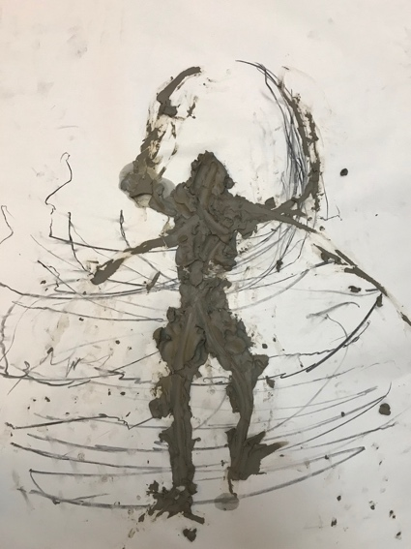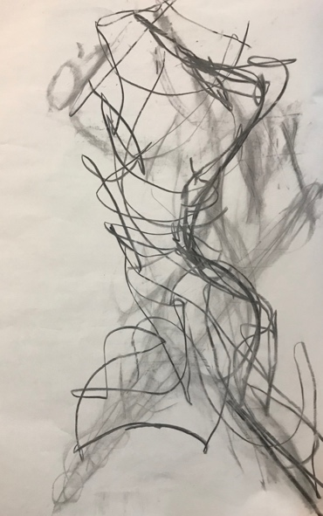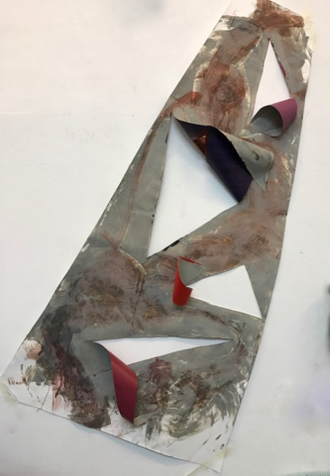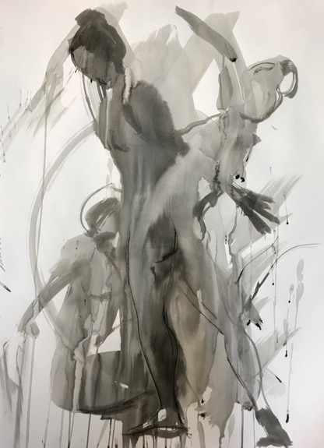
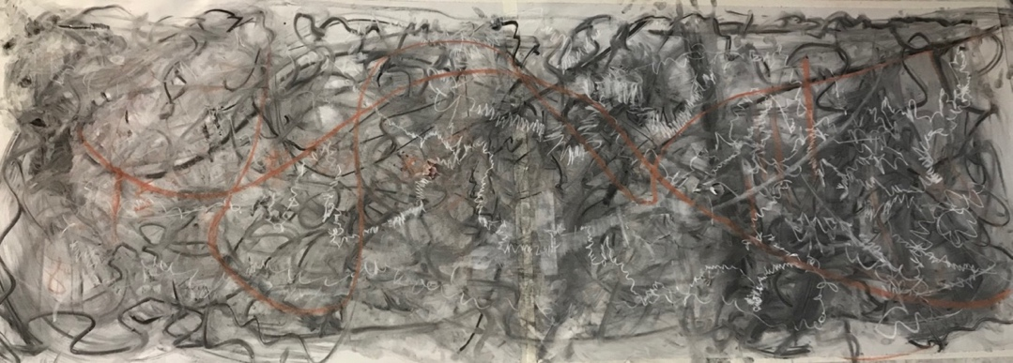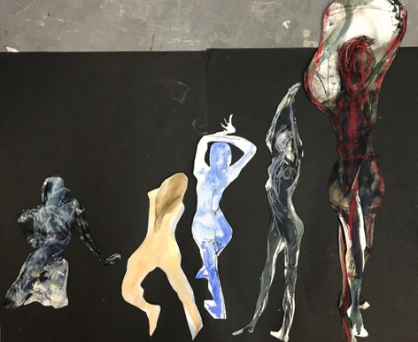

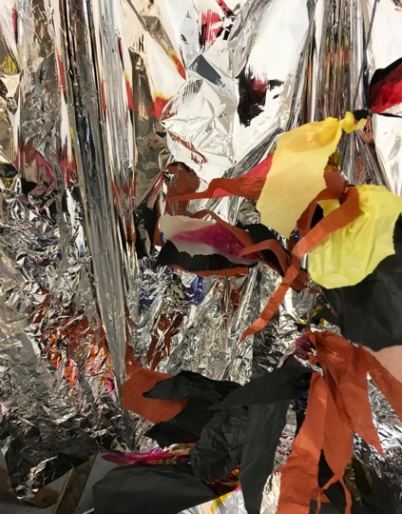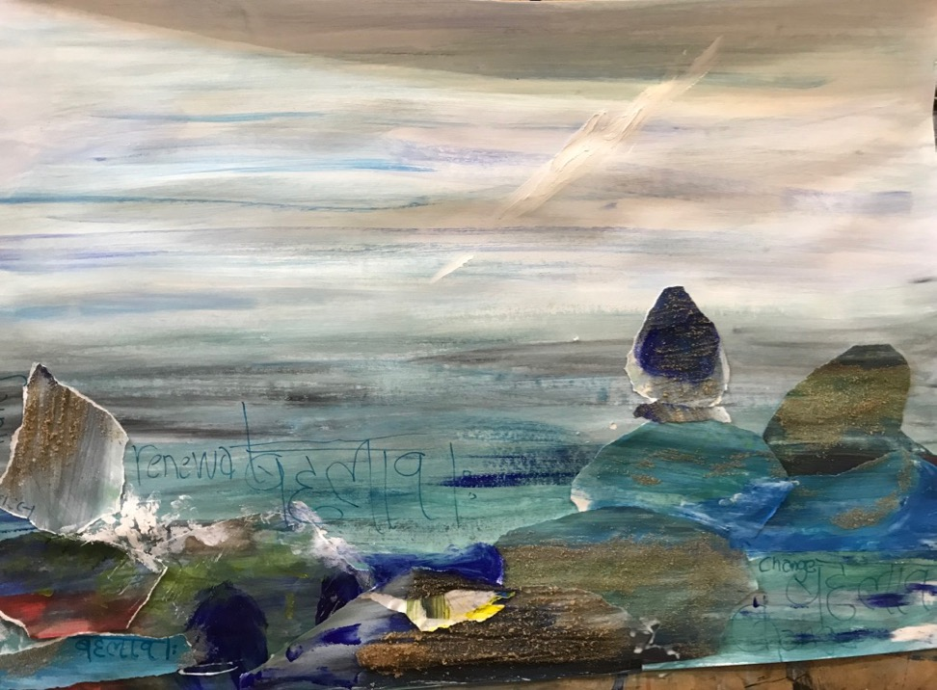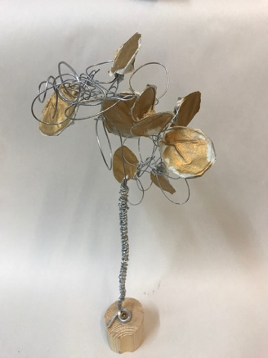

Light and Colour Unboxed

This course explores the nature of light and colour and our relationship to luminosity and darkness. We will look at how different artists’ use light and colour in their work from 2D, 3D and light installations to convey different emotions. Students will continue to learn about colour and colour mixing. They will explore the role different degrees of colour and light play in their lives via experimenting with drawing, painting and sculpture and how to apply this to embody different experiences. Students will be encouraged to consider how they can work with light and colour to en-lighten their creative practice.

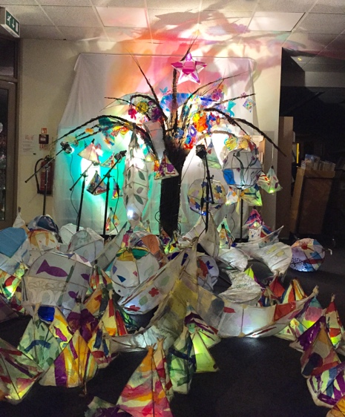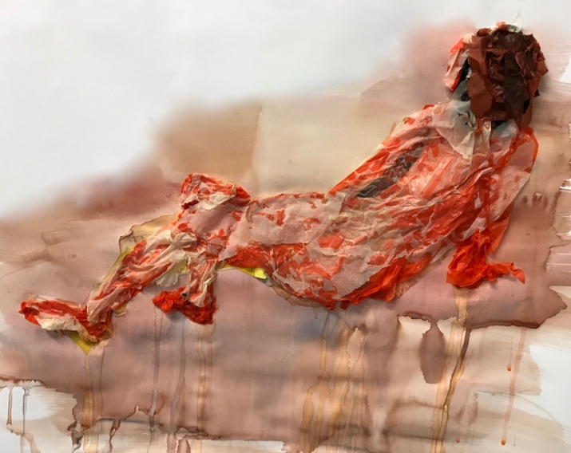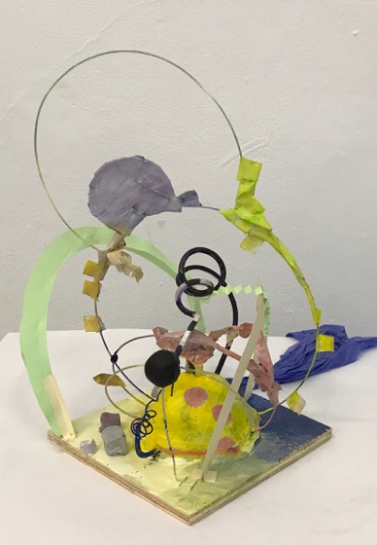

Music and Sound Art unboxed This course explores sound, music and song to trigger creative processes. Working with sound as an artistic medium can open up whole new landscapes. Students will be introduced to listening, recording and performing sound and its tactility. We will consider different artists who were directly influenced by music and how it affected their practice. We will then explore how different types of music and sound can be responded to in paint including action painting, mixed media and other materials.

The Unexpected Unboxed This course explores methods to reach and enable expression of aspects of students’ creativity which may otherwise be untapped. Specific creativity exercises including those used by Surrealistic and DaDa artists will be undertaken to enable unexpected creative discovery. The course will include a journey from collage and painting to assemblage and installation. New skills will be discovered alongside exciting artistic developments.

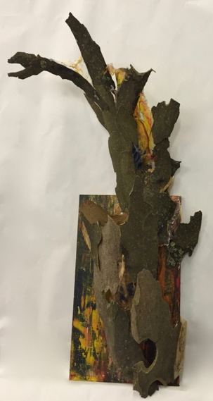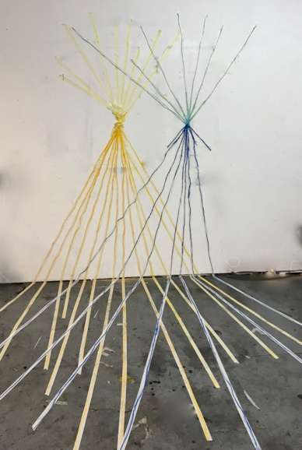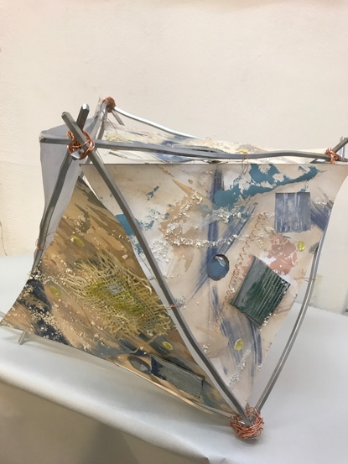

THE BIGGER PICTURE
Deep Time Unboxed This course aims to help students to connect creatively to some of the big questions as an artist as well as in life, such as: who are we?, where do we come from?, where are we going? and what do we have to contribute? In the context of the cosmological unfolding of our universe (http://journeyoftheuniverse.com, https://deeptimejourney.org), with the aim of connecting to deep time, we will explore how just as our planet is on an evolving journey, so are we as a human species. Within this context, each person can make a difference if only they can identify how. We will explore this via a range of creative expressive mediums. It is recognised that we are all made up of and are transforming from the same elements as Stars and Stardust.
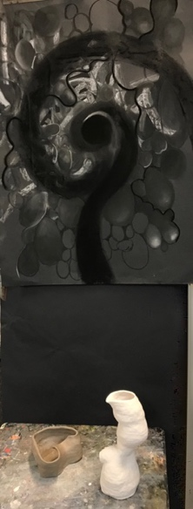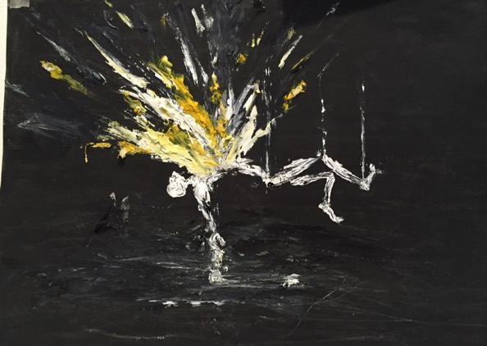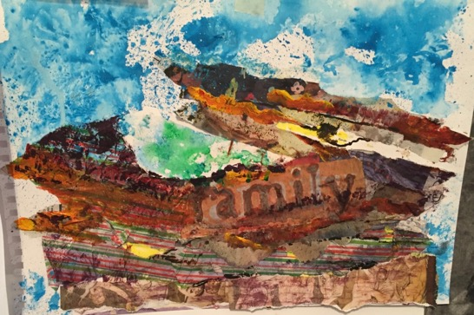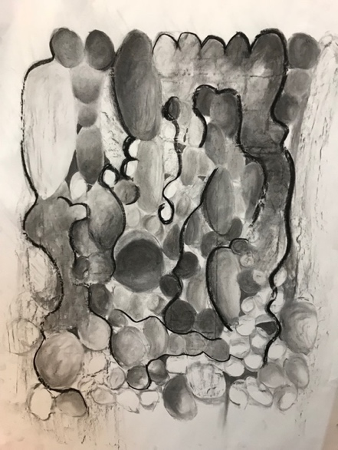
ADDITIONAL COURSES
Life Drawing Unboxed Different approaches to drawing the life model are explored. A wide range of techniques and approaches to include line drawing, gestural and rhythmic drawing, tonal work, weight, movement and stillness using a wide range of materials including – pencil, charcoal, conte, pastels, pen and ink, paint, collage. Students will then apply what they have learnt to a theme to create a final piece.
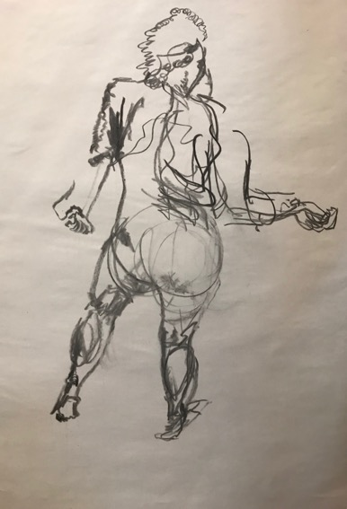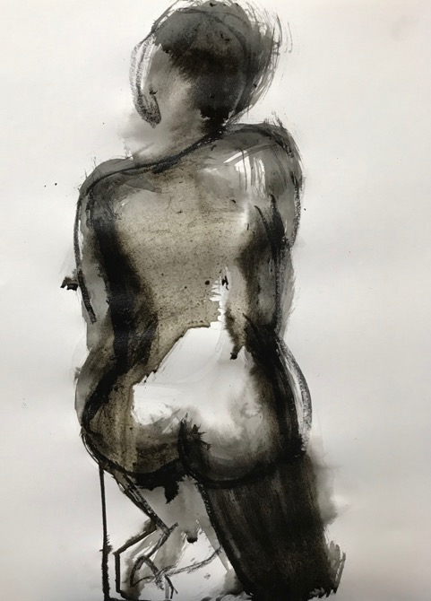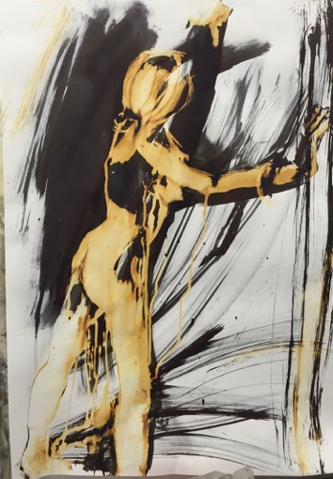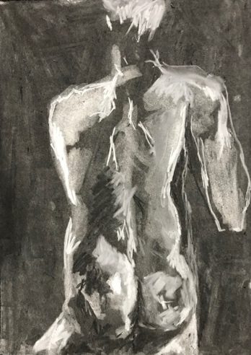
Drawing Unboxed This course challenges the traditional boundaries of drawing by expanding its application from 2D to 3D and beyond. Inspired by contemporary as well as traditional practice students are invited to connect to multiple senses via drawing to incorporate light, colour, sound, movement, gesture, language, photography, sculpture and installation.
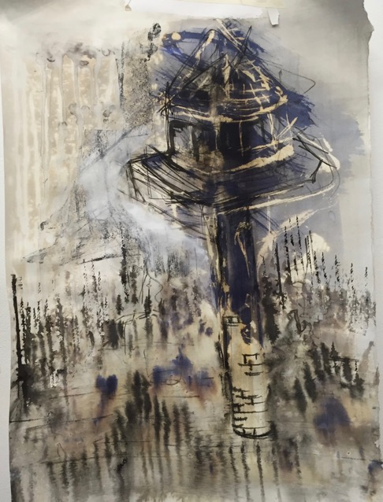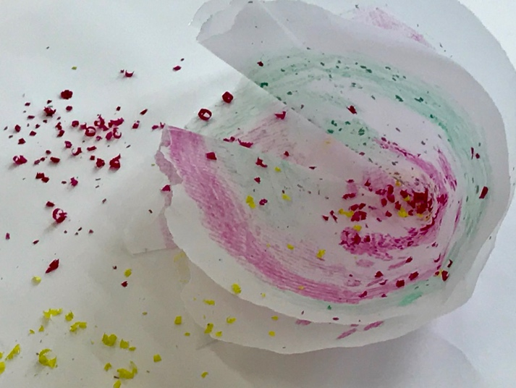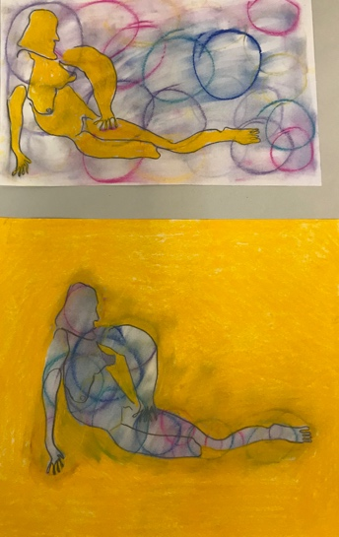

COURSES FOR YOUNG ARTISTS Courses for young artists are offered to provide high level art tuition, including drawing workshops, contemporary painting, specialist sculpture techniques and the use of experimental and collage mediums.
Classes or individual tuition provides a supportive environment with a strong focus on personal outcomes and solutions to develop independent judgement. Specialist materials are used to improve technical skills while discussion and presentation sessions build confidence and critical understanding. Ideal for students of all skill levels, from those looking to advance their artistic skills and creative confidence to those looking to increase an interest in an area that isn’t their favourite!
Other Courses available:
- Fundamental skills of drawing - Introduction to the fundamentals of drawing, including line, tone, and gesture and exercises to trigger imaginative drawing.

- Fundamental skills of painting - Students will explore colour, composition, and paint application through still life painting and creative painting session which introduces music and movement.

- Life drawing - Working with the life model, exploring different traditional and experimental approaches using a range of materials to learn observational drawing and open up creative expression. Includes gestural drawing, line drawing, tonal drawing, composition, measurement

- Life Painting - Starting with a presentation of the body in art, students will develop a full painting of the life model. Students will learn key skills to observe and depict the figure, along with basic anatomy, and composition.

- Creative sculpture- Explore a wide range of sculptural, language, materials and processes to apply to their own creative theme. Specific focus can be eg Creative plaster or Wire work.

- Model making for architectural and set design.

- Introduction to portraiture – drawing, painting or sculpture

- Sculpting the figure in clay - An introduction to the principles of figure sculpture. Students will then learn how to model the figure and complete a full pose over the day. This can be developed imaginatively.

- Creative Installation – Exploring assemblage, installation and performance as 3D methods of exploration

- Mixed media and the imagination - contemporary artists’ approaches, incorporating collage, texture and colour. Create 2D/3D mixed media pieces on their life story/what they love most.

- Willow sculpture and Lantern making

- Printing processes - mono printing, lino printing, Collography

- Wisdom Star Values workshop

- Exploring Colour, abstraction and colour theory with applications

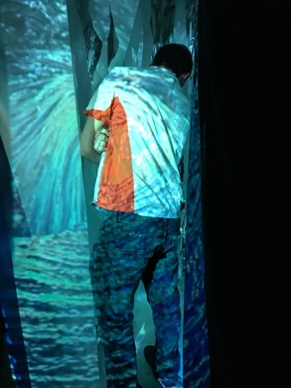
TESTIMONIALS - WORKSHOPS

"Unlocking Creativity is an inspirational course that helped me to reconnect with the artistic experience through the process of making. Lorna is a fantastic and supportive teacher who encourages you to explore creativity as part of a self-development process. It is incredible how many mediums you can experiment with in just one week, being motivated to develop your own personal project which culminates in a final piece. It has been rewarding to see how productive you can be simply by following your creativity. I went back to my work and my writing more motivated and inspired. The course is both for people working in the artistic and creative sectors as well as for those interested in approaching these fields in search of the creative moment."
Sara Buoso, PhD candidate, UAL, 2018

“Lorna is a fantastic facilitator-teacher who skilfully provided sufficient structure while providing space for each person to follow their interests and further their explorations in a group setting…. She is brilliant at facilitating creative processes in people…..I found the focus on connection and process particularly freeing and allowed creativity to flow unhindered. Exposure to different medium provided multiple sources of inspiration and possibilities.

The week was one of the best courses I have ever been on!
It re-connected me with passion and the life-force of creativity as well as opening up surprising avenues of interests that I hadn't previously considered. I was reconnected with the spaciousness of exploring through the different medium deep interests in phenomena, existence, relationships, being, mystery the invisible, divinity. It presented a breakthrough in terms of approaching something in my own terms and allowing what is truly wanting to be expressed to be expressed….. An immediate outcome was the completion of a piece of writing for a journal that had been stuck for over a month- it took 2 days- the article almost wrote itself. I recognise now how core creativity is to me….”
Amy Barnes, Corporate Consultant, Facilitator, Mentor, August 2017

"I really want to thank you for the whole of last week. I am full of joy for having discovered both a new passion and a new capability. I realized that it is the first time ever in my life I am producing and creating something coming from me. Education, studies and most of my work so far had been only learning, taking in knowledge and using/reproducing it to get the good marks, get things right and show I am able and can do what I am expected to do. So now, I started creating myself and my mind is boiling with ideas and projects since Friday night! So Big Big Thank you again for introducing me to this new chapter of my life."
Catherine, International PR Director, August, 2016
​
" There was so much opportunity to problem solve independently and together. Exceptional teacher, Lorna was able to create the environment and support to creatively free me up. Very enriching valuable experience." Debbie Robson, August 2016

"Thank you so much for a really great week. I learnt more in that week then I have in years of art lessons." Lucy Farrow, GCSE student, August 2015

"Thank you for creating such a supportive, creative and freeing week! This course has been phenomenal, illuminating and inspiring both from an art technique and personal development perspective. I don’t know how she achieved it, but Lorna has created something very special."
Charlotte Smith, London, August 2015
SELECTED ARTWORK BY YOUNG ARTISTS Aged 12-16

